The History of the Missing
Ben Chamo PERFUME PORTRAITS VILLA SELIGMANN

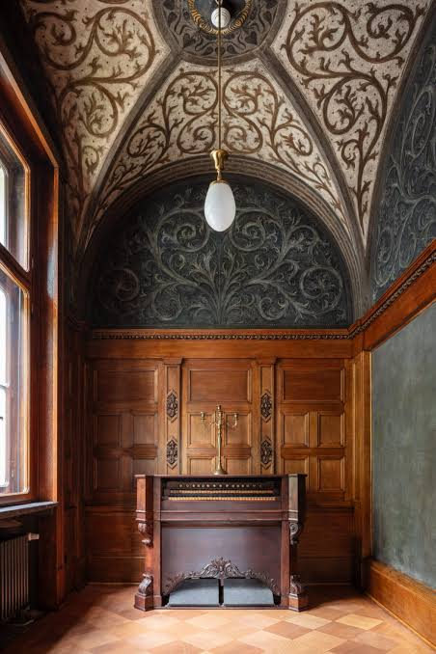

This magnificent suite with five neo-baroque paintings that celebrate the human senses was commissioned in 1906 by the artist Ferdinand Wagner and commissioned for the large staircase of the Villa Seligmann.

For decades, these five allegorical works were proud symbols of Jewish-bourgeois cultural life in Hanover. The economic upheavals of 1931 forced the Seligmann family to auction off the entire inventory of the villa and disperse the collection. While hearing, sight and taste survived the turbulent decades, the last two chapters of the series - touch and smell - were permanently destroyed during the air raids of World War II.

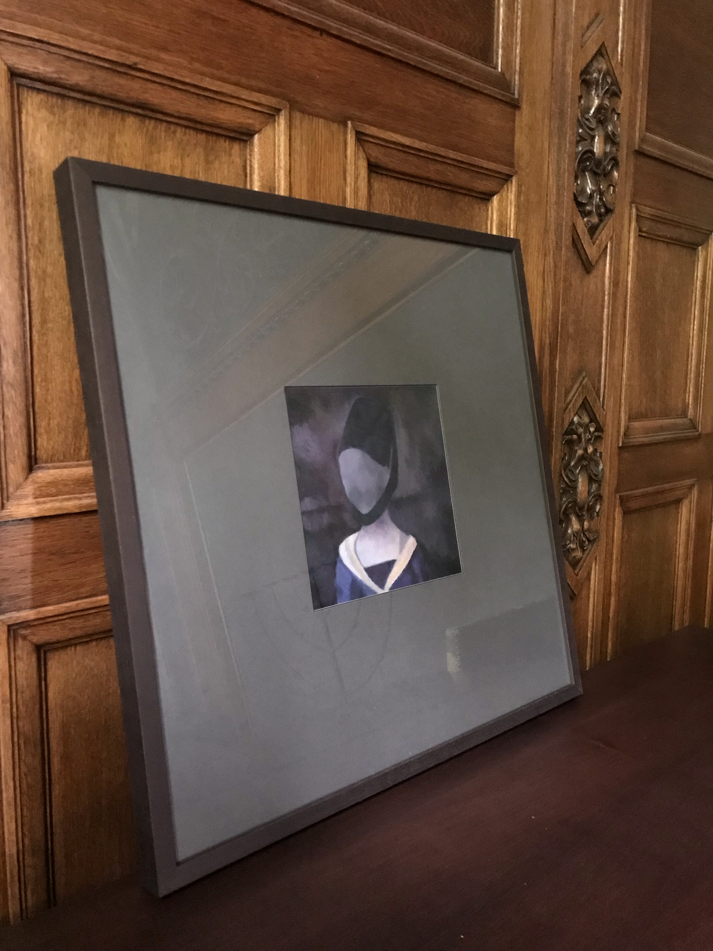
The Perfume Portraits Villa Seligmann

The return of the senses

When the three preserved masterpieces finally returned to their original walls in 2023, they framed two agonisingly empty gaps. To heal this architectural scar, contemporary conceptual artist Avi Albers Ben Chamo stepped forward to recreate the missing limbs. Instead of painting static imitations of the past, Ben Chamo re-envisioned the missing senses through an interactive lens. His Perfume Portraits serve as a physical dialogue and as a message of human connection.

Revitalising the Emptiness

The first break in this historic cold case took place in 2025. During the spectral silence of Hanover's Night of the Museums, Ben Chamo staged a radical intervention entitled "TOUCH: An Artwork of Encounter". The performance was a shocking, physical plea for a tangible connection in an increasingly distant world. Nevertheless, the atmosphere remained incomplete; a final piece of the puzzle - "Smell" - was still hanging in the aether, waiting for its physical coordinates to be restored.

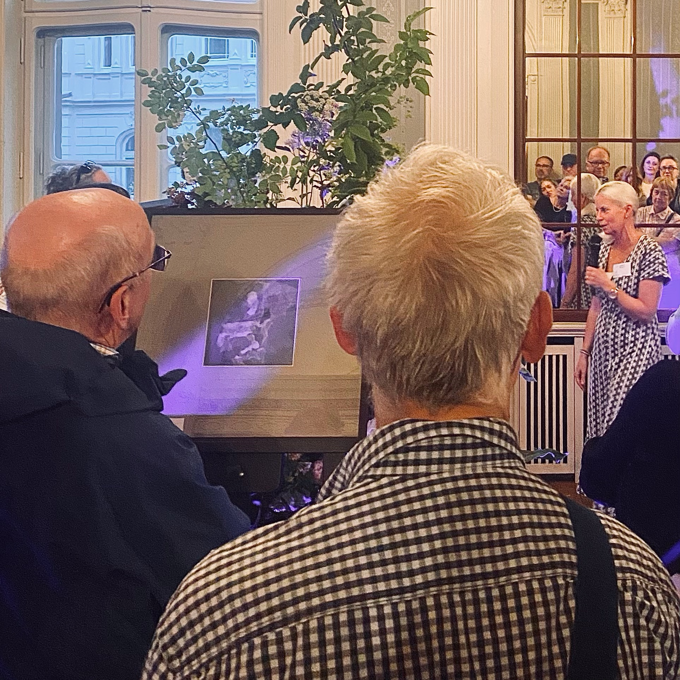
The Perfume Portraits Nacht der Museen Hanover

After 92 years, the paintings "The Taste", "Seeing" and "Hearing" return to their original hanging place in the Villa Seligmann. Read-
https://villa-seligmann.de/historisches-ereignis-die-villa-seligmann-erwirbt-kunstwerke-der-originalusstattung/

The Return: The Lost Allegory

Avi Alber's Ben Chamos The Perfume Portraits reinterprets the lost allegory of smell in the Villa Seligmann and translates the historical memory into fleeting forms of smell. The series allows visitors to breathe in the remnant of the past of the villa and to bridge the gap between pre-war Elegance and the present. Through the visceral immediacy of the fragrance memory, Ben Chamo makes absolute absence as a tangible, lively sensory experience.

Exhibition history

The perfume portraits were presented as a central highlight during the night of the Museums, June 2026 in the cultural centre Villa Seligmann in Hanover and then shown at the annual summer festival of the Villa 120th anniversary.

Related Lecture
The Perfume Portraits
"Old masters, new views"

Art historian Dr. Llane Fragoso Maldonado gave a lecture that accompanied the exhibition and explored the creation of The Perfume Portraits. Dr. Fragoso Maldonado's research focusses on Renaissance art networks and early modern northern Italian painting around 1500, including the workshop of Leonardo da Vinci.

Portraits
Ben Chamo

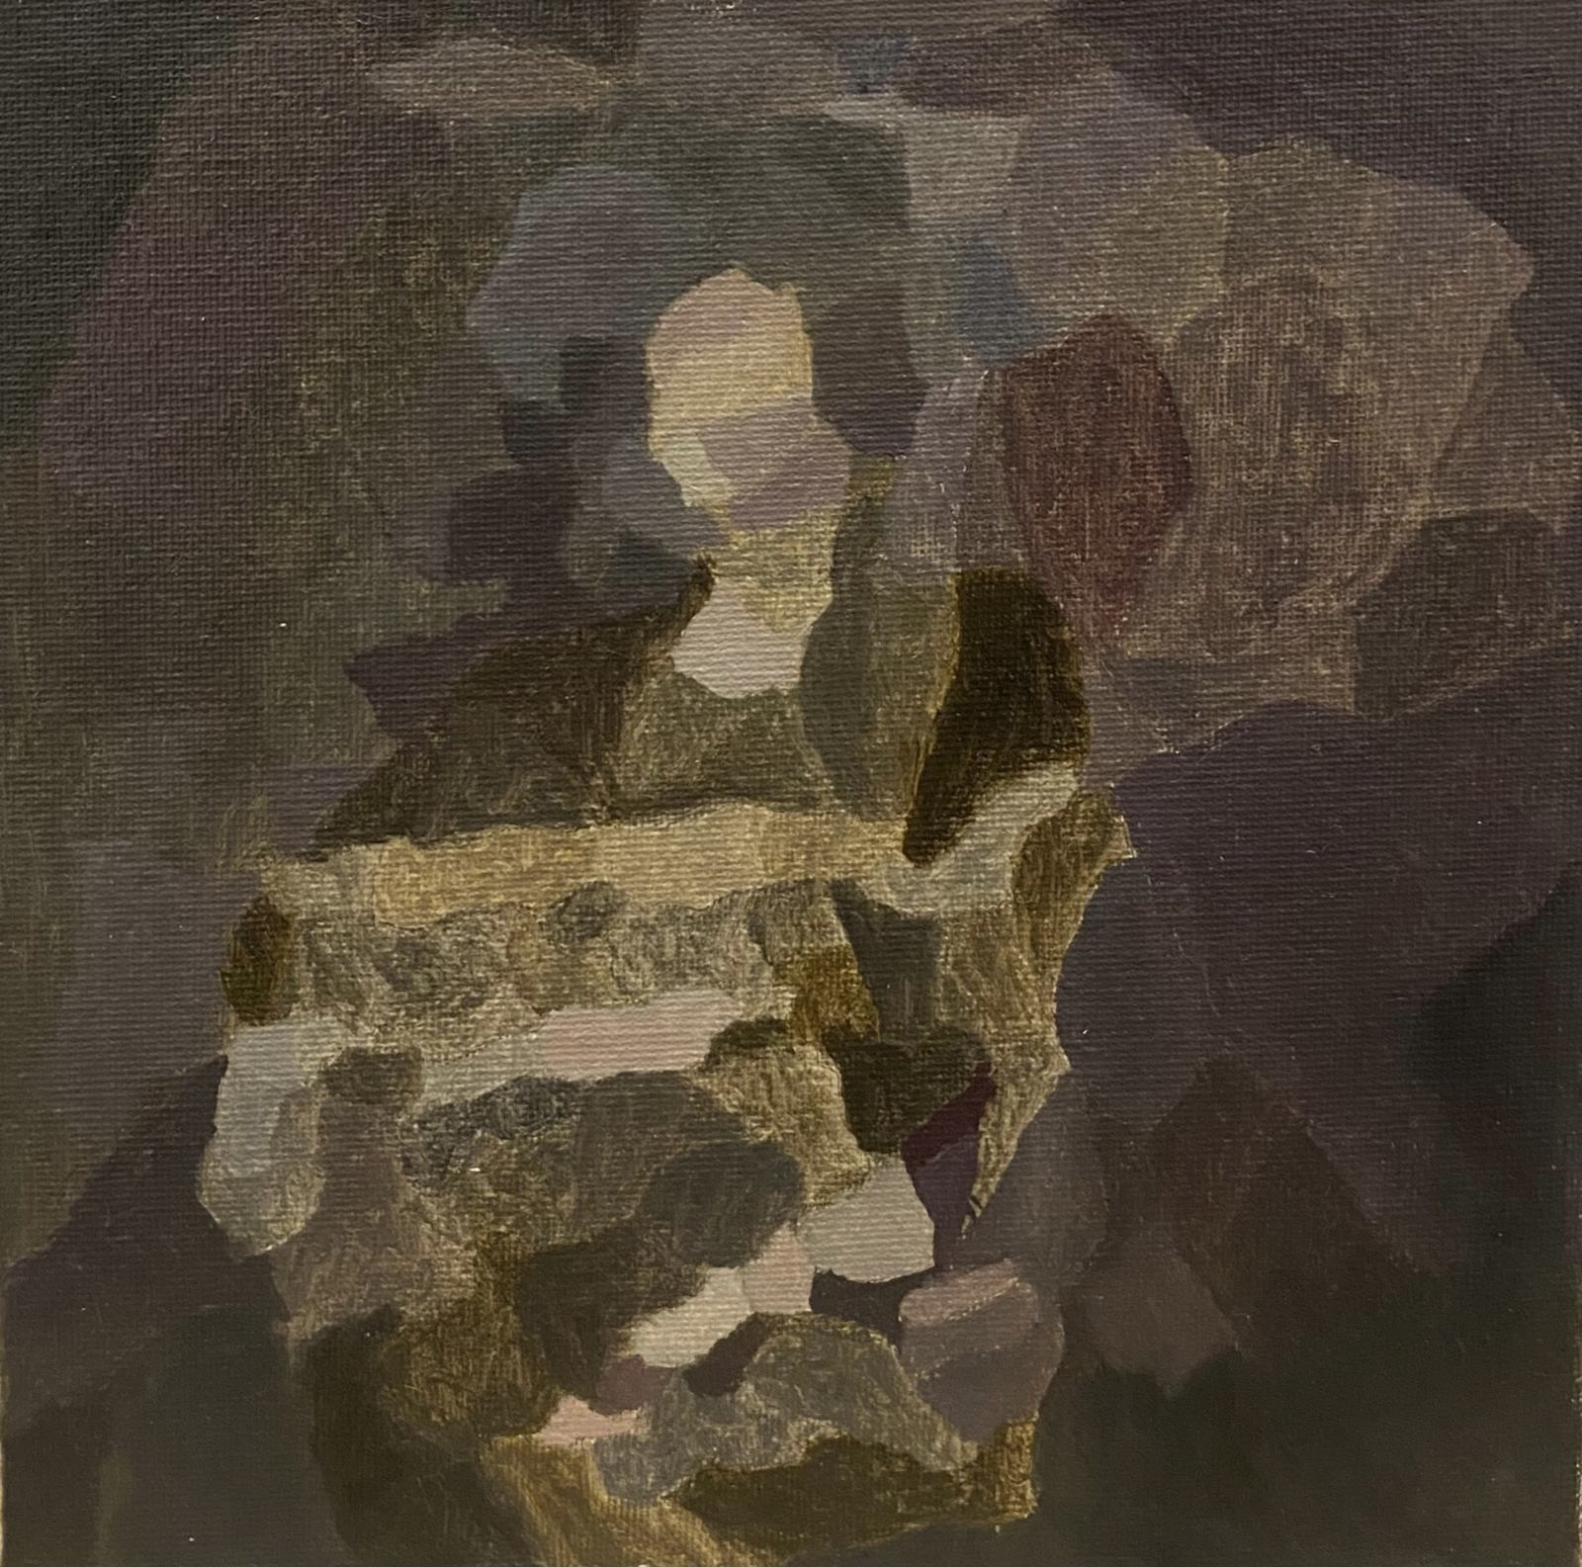
Portrait of Idealista

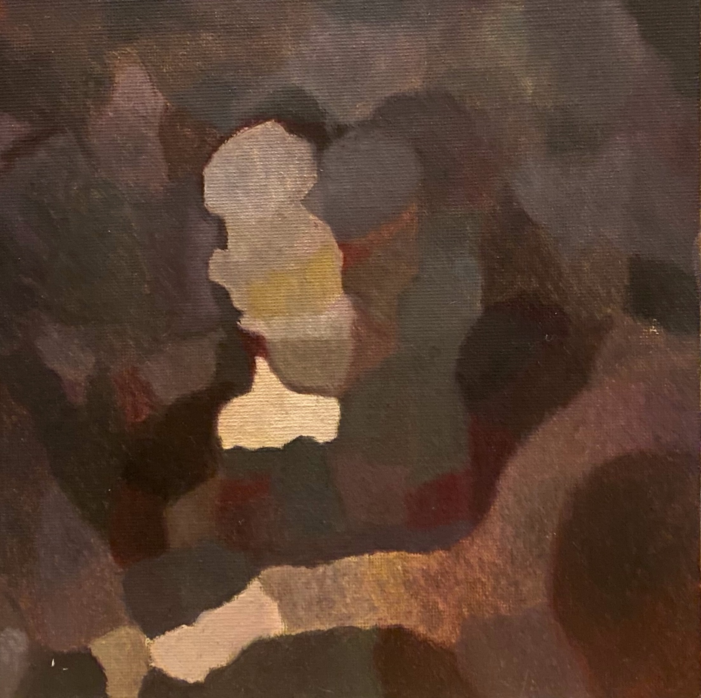
Portrait of Rabi Messas

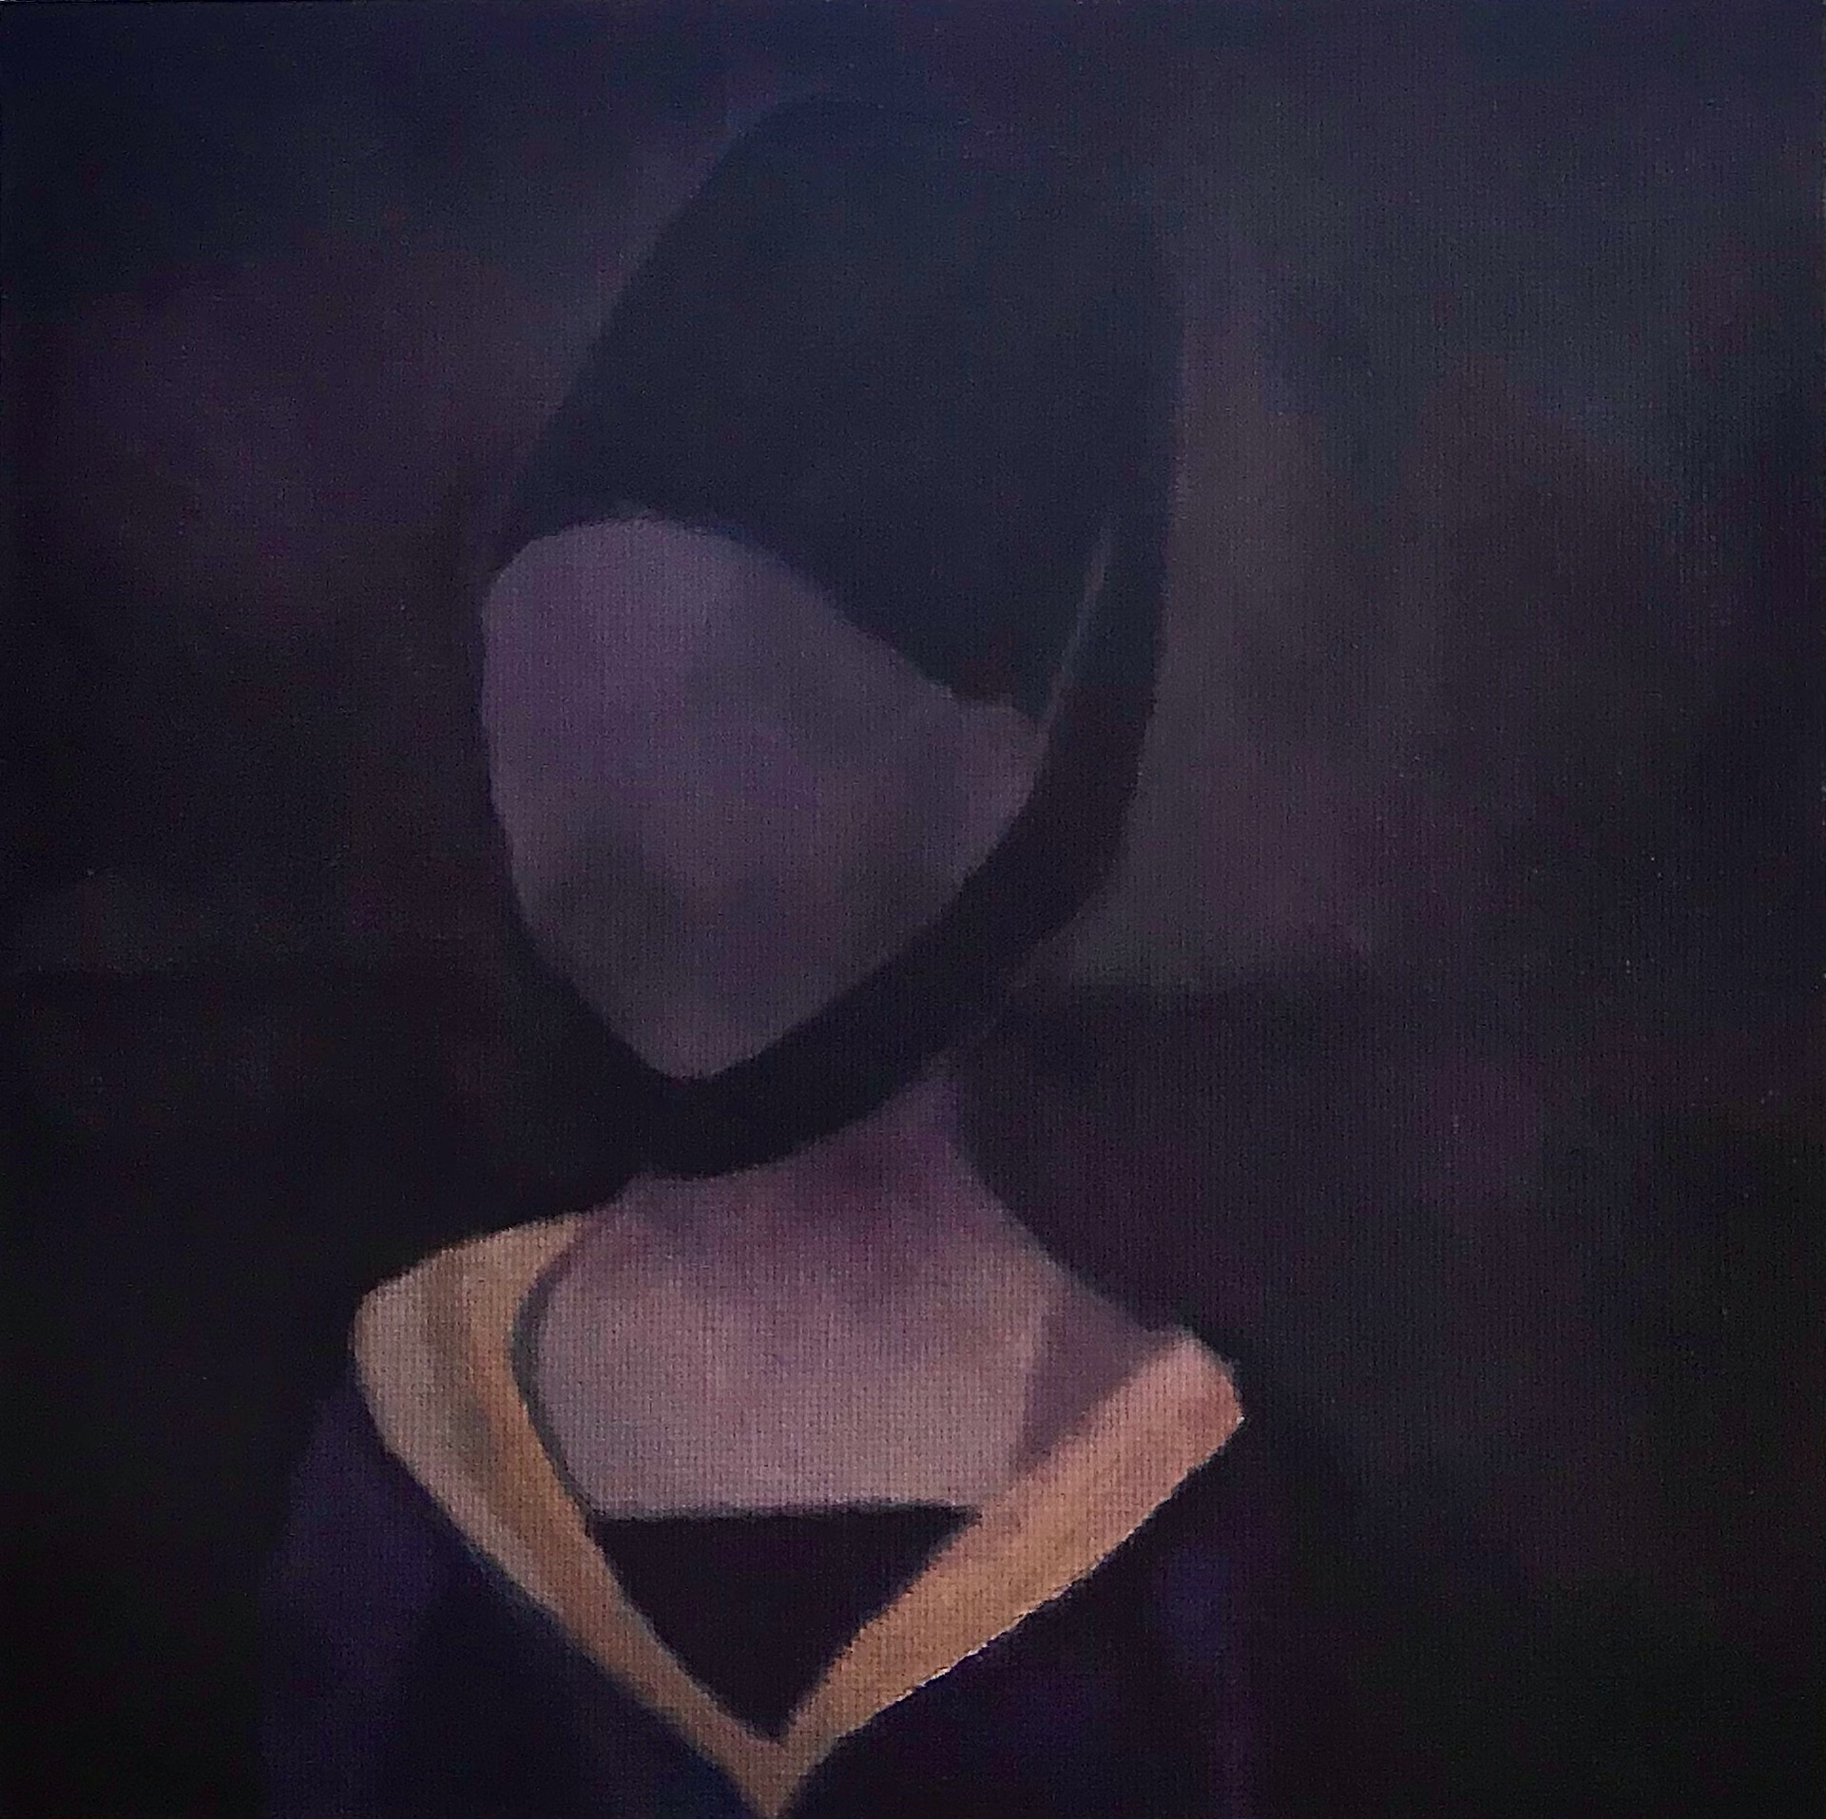
Hannah's Window

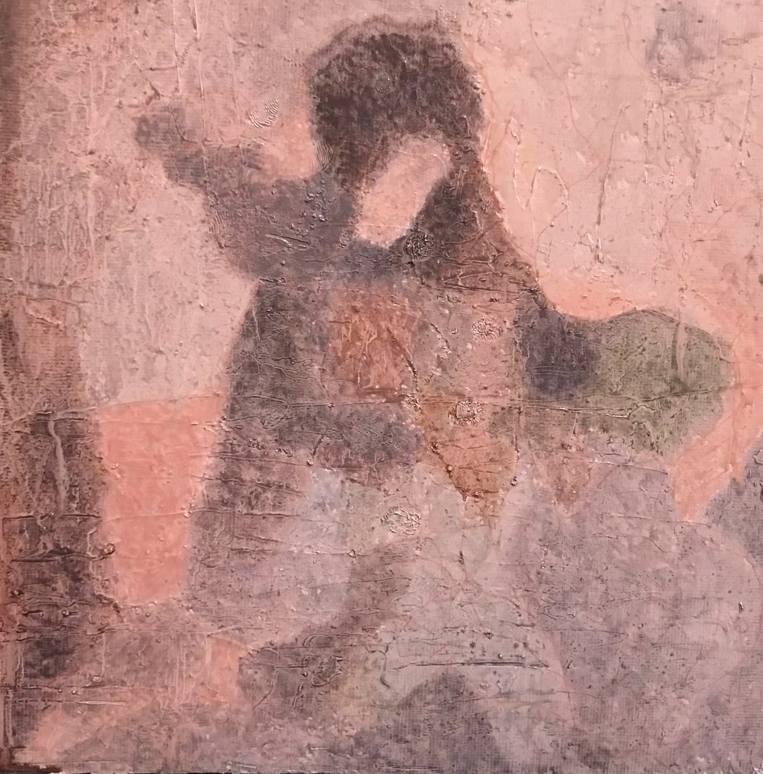
Portrait of Cherry Blossom Girl

Specifications
Dimensions: Painting: 20 × 20 cm | Frame: 50 × 50 cm
Authentication: Hand-signed by the artist on each piece.

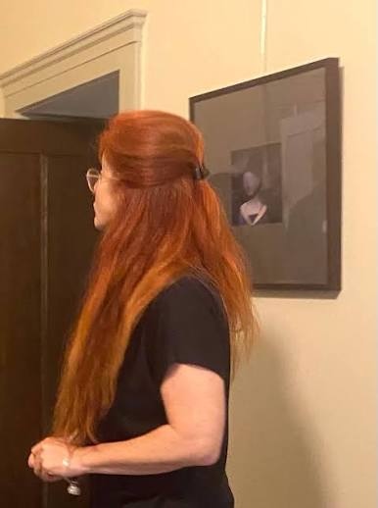

All four works of art arrive framed,
With free shipping included.

Single Work (from the series)
Oil on canvas
20 x 20 cm
€1,500

Complete Series
Full Series Portfolio
Complete set of four unique paintings
€5,000

Ben Chamo Atelier Grunewaldstraße. 76/ 10823 Schöneberg, Berlin Germany
avi1benson@gmail.com /+49 1575 277 5203

